Quiz
Unit 1: Robotics Intro
Name:_________________________ Period:___ Date:________ Score:_____/20

- (3 pts) Give an example of a robot (real or fictional) and describe how it:
  - senses its environment
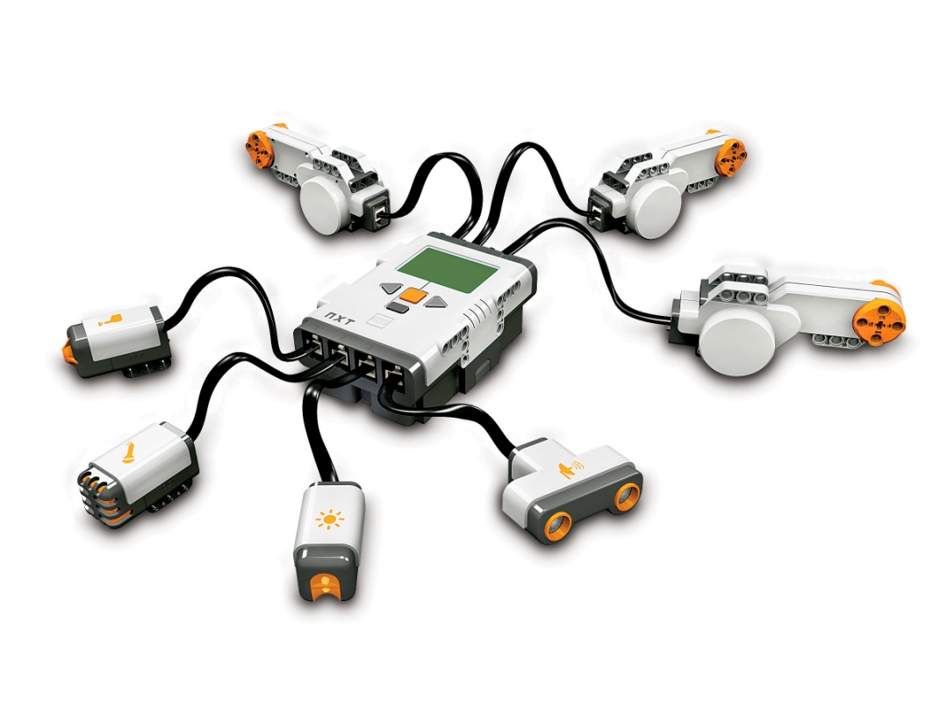
  - responds to instructions
- (7 pts) Use this picture to identify 7 different electronic components:
- (5 pts) Explain how these 3 pegs are different (other than their color). Give an example of how 2 of them could be used:
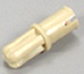 (color: tan)
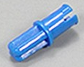 (color: blue)
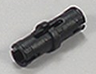 (color: black)
- (3 pts) Name this part, and describe 2 ways it can be used:

- (2 pts) To maximize speed in a gear train, explain how the crank and wheel should be connected to the largest and smallest gears. Why? (Hint: think of a multi-speed bicycle going down a steep hill)

